AI-Lingo
Contextual Language Immersion App
Database Design & Data Modeling

1. Introduction
This document describes the database design for AI-Lingo, a Flutter mobile application that generates AI-based English conversations, evaluates the learner's responses, manages vocabulary, and tracks progress. It contains the ER diagram, the logical schema (tables, attributes, keys, and normalization), and the physical schema for the two storage technologies used by the project: Cloud Firestore and Hive.
The design is based on the project plan, the functional requirements (FR-01 to FR-22), the non-functional requirements, and the System Analysis & Design document (use cases UC-01 to UC-09 and the MVVM architecture).

1.1 Design Approach
- Logical first: The logical model is relational (entities, keys, and normalization) so that the data structure is clear and consistent.
- Physical second: Firestore and Hive are NoSQL stores, so the physical model maps the logical tables to collections, documents, and boxes, embedding data that is read together.
- Privacy by design: every learner's data is private and stored under users/{uid}; only the minimum data needed for the learning features is kept.
- Extensible: new scenarios, categories, and languages are added as data, not as schema changes (NFR-08).

2. Data Storage Strategy
Store | What it holds | Why
Firebase Authentication | Accounts and credentials (email/password, Google) | Secure credential handling; no passwords in our database
Cloud Firestore | Source of truth for each learner's profile, lessons, messages, vocabulary, and progress | Cloud backup and sync across devices (FR-11, FR-21)
Hive (encrypted) | Local copy of vocabulary and progress, downloaded lessons, sync queue, and settings | Offline access and fast loading (NFR-01, NFR-06)
Gemini (Firebase AI Logic) | Not a database: generates dialogues and evaluations; results are saved to Firestore/Hive | No API key in the app; only necessary data is sent (NFR-03, NFR-09)

The Model layer of the MVVM architecture reaches these stores through four repositories:
Repository | Data sources
Auth Repository | Firebase Authentication, users/{uid}
Conversation Repository | Gemini, lessons, messages, scenarios, assessments, offlineLessonsBox
Vocabulary Repository | users/{uid}/vocabulary, vocabularyBox, syncQueueBox
Progress Repository | users/{uid}/progress/summary, progressBox

3. Entity Identification
The model contains 14 entities, grouped by color in the ER diagram.
Entity | Group | Description
USER | Users & Profile | A learner account. Profile, learning settings and app preferences (credentials stay in Firebase Authentication).
CATEGORY | Catalog | A topic area used both as a learner interest and as a scenario category (e.g., Travel, Job Interview, Restaurant).
USER_INTEREST | Users & Profile | Junction table: interests selected by a learner (many-to-many between USER and CATEGORY).
LEVEL_ASSESSMENT | Users & Profile | One attempt of the placement test or an automatic level update, kept as history.
SCENARIO | Catalog | A conversation situation. Predefined scenarios have no creator; custom scenarios belong to a user.
LESSON | Learning | One AI-generated conversation session for a learner and a scenario. Also serves as the conversation history (FR-19).
MESSAGE | Learning | One turn in a lesson, written either by the AI or by the learner.
CORRECTION | Learning | A mistake detected in a learner message, with the corrected text and a short explanation (FR-11).
EVALUATION | Learning | AI evaluation of a completed lesson (grammar, vocabulary, and conversation performance).
WORD | Vocabulary | A dictionary entry shared by all learners.
WORD_TRANSLATION | Vocabulary | Translation of a word into a learner's native language (supports new languages without schema change).
LESSON_WORD | Vocabulary | Junction table: words that appear in a lesson, and whether they were new to the learner (FR-08, FR-09).
USER_WORD | Vocabulary | A word saved by a learner, with review history used to mark it as learned (FR-14 to FR-16).
USER_PROGRESS | Progress | Summary counters for the dashboard (one row per learner), stored on purpose to avoid recounting on every screen load.

4. ER Diagram
Each entity shows its primary key (PK), foreign keys (FK), and main attributes. The complete attribute list is in Section 5.

Figure 1: AI-Lingo Entity-Relationship Diagram (Chen notation) showing the key and main attributes of each entity.
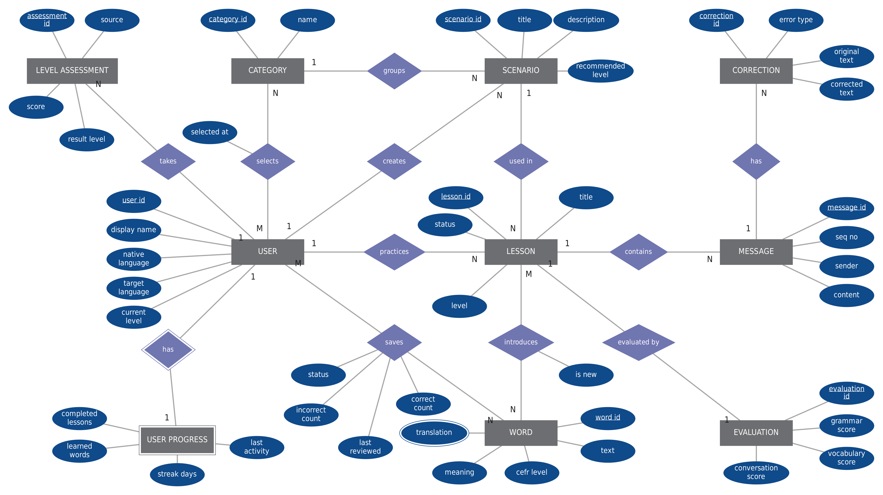
Notation: rectangle = entity (double = weak entity), diamond = relationship, ellipse = attribute (underlined = key, double = multivalued). 1 / N / M = cardinality.

Figure 2: AI-Lingo Entity-Relationship Diagram (crow's foot notation)
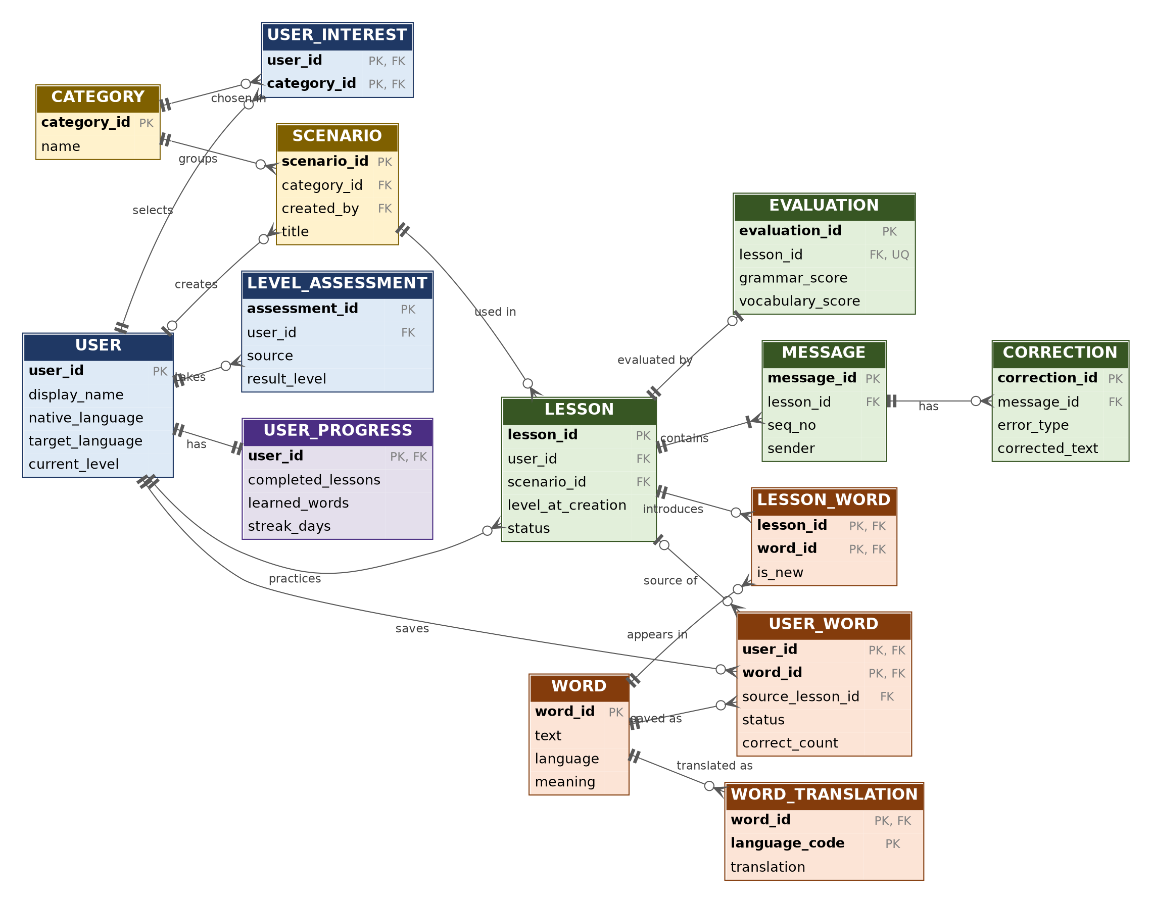
Notation: || exactly one |o zero or one o< zero or many |< one or many. Colors: blue = users, yellow = catalog, green = learning, orange = vocabulary, purple = progress.

4.1 Relationships
Parent | Child | Cardinality (parent : child) | Meaning
USER | LEVEL_ASSESSMENT | 1 : 0..N | takes
USER | USER_INTEREST | 1 : 0..N | selects
CATEGORY | USER_INTEREST | 1 : 0..N | chosen in
CATEGORY | SCENARIO | 1 : 0..N | groups
USER | SCENARIO | 0..1 : 0..N | creates
USER | LESSON | 1 : 0..N | practices
SCENARIO | LESSON | 1 : 0..N | used in
LESSON | MESSAGE | 1 : 1..N | contains
MESSAGE | CORRECTION | 1 : 0..N | has
LESSON | EVALUATION | 1 : 0..1 | evaluated by
LESSON | LESSON_WORD | 1 : 0..N | introduces
WORD | LESSON_WORD | 1 : 0..N | appears in
WORD | WORD_TRANSLATION | 1 : 0..N | translated as
USER | USER_WORD | 1 : 0..N | saves
WORD | USER_WORD | 1 : 0..N | saved as
LESSON | USER_WORD | 0..1 : 0..N | source of
USER | USER_PROGRESS | 1 : 1 | has

Key design decisions
- One category list: Interests and scenario categories use the same CATEGORY table, so a learner's interests directly filter the scenario list.
- Lesson = conversation: LESSON is one AI conversation session, so it also serves as the history of past conversations (FR-19).
- Predefined and custom scenarios in one table: created_by is NULL for predefined scenarios and holds the user ID for custom ones (FR-06).
- Words are shared: USER_WORD links a learner to a shared WORD, and LESSON_WORD links lessons to words, which makes new-word highlighting and auto-save simple (FR-08, FR-09, FR-14).
- Level history: LEVEL_ASSESSMENT keeps the placement test and later automatic updates as history, while USER.current_level holds the latest level.

5. Logical Schema
Key legend: PK = primary key, FK = foreign key, UQ = unique, UQ* = unique together with the other starred attribute. Types are logical types; Firestore and Hive types are given in Section 7.
USER
A learner account. Profile, learning settings and app preferences (credentials stay in Firebase Authentication).
Attribute | Type | Key | Description
user_id | String | PK | Firebase Authentication UID
display_name | String |  | Name shown in the app
auth_provider | Enum |  | email | google
native_language | String(2) |  | ISO 639-1 code (FR-02)
target_language | String(2) |  | ISO 639-1 code, default 'en'
current_level | Enum |  | CEFR A1–C2, NULL until placement (FR-04, FR-05)
app_language | String(2) |  | Interface language (FR-22)
theme | Enum |  | light | dark | system (FR-22)
notifications_enabled | Boolean |  | Default true (FR-22)
reminder_time | Time |  | Optional daily reminder (FR-18)
created_at | Timestamp |  | Account creation time
last_active_at | Timestamp |  | Last app activity
CATEGORY
A topic area used both as a learner interest and as a scenario category (e.g., Travel, Job Interview, Restaurant).
Attribute | Type | Key | Description
category_id | String | PK | Unique identifier
name | String | UQ | Category name
description | String |  | Short description
USER_INTEREST
Junction table: interests selected by a learner (many-to-many between USER and CATEGORY).
Attribute | Type | Key | Description
user_id | String | PK, FK | References USER
category_id | String | PK, FK | References CATEGORY
selected_at | Timestamp |  | When the interest was chosen
LEVEL_ASSESSMENT
One attempt of the placement test or an automatic level update, kept as history.
Attribute | Type | Key | Description
assessment_id | String | PK | Unique identifier
user_id | String | FK | References USER
source | Enum |  | placement_test | auto_update | manual
status | Enum |  | in_progress | completed
score | Integer |  | 0–100, NULL until completed
result_level | Enum |  | CEFR A1–C2, NULL until completed
started_at | Timestamp |  | Start time
completed_at | Timestamp |  | NULL until completed
SCENARIO
A conversation situation. Predefined scenarios have no creator; custom scenarios belong to a user.
Attribute | Type | Key | Description
scenario_id | String | PK | Unique identifier
category_id | String | FK | References CATEGORY, optional for custom scenarios
created_by | String | FK | References USER; NULL = predefined scenario
title | String |  | Scenario title (FR-06)
description | String |  | Situation description used in the AI prompt
recommended_level | Enum |  | Optional CEFR level
created_at | Timestamp |  | Creation time
LESSON
One AI-generated conversation session for a learner and a scenario. Also serves as the conversation history (FR-19).
Attribute | Type | Key | Description
lesson_id | String | PK | Unique identifier
user_id | String | FK | References USER
scenario_id | String | FK | References SCENARIO
title | String |  | Lesson title
level_at_creation | Enum |  | CEFR level used for generation (FR-07)
status | Enum |  | generated | in_progress | completed
ai_model | String |  | Model name, for traceability
created_at | Timestamp |  | Generation time
completed_at | Timestamp |  | NULL until completed
MESSAGE
One turn in a lesson, written either by the AI or by the learner.
Attribute | Type | Key | Description
message_id | String | PK | Unique identifier
lesson_id | String | FK | References LESSON
seq_no | Integer | UQ* | Order inside the lesson; unique with lesson_id
sender | Enum |  | ai | user
content | Text |  | Message text
created_at | Timestamp |  | Time sent
CORRECTION
A mistake detected in a learner message, with the corrected text and a short explanation (FR-11).
Attribute | Type | Key | Description
correction_id | String | PK | Unique identifier
message_id | String | FK | References MESSAGE (learner messages only)
error_type | Enum |  | grammar | vocabulary
original_text | String |  | Learner's wording
corrected_text | String |  | Suggested wording
explanation | String |  | Short explanation
EVALUATION
AI evaluation of a completed lesson (grammar, vocabulary, and conversation performance).
Attribute | Type | Key | Description
evaluation_id | String | PK | Unique identifier
lesson_id | String | FK, UQ | References LESSON (one evaluation per lesson)
grammar_score | Integer |  | 0–100
vocabulary_score | Integer |  | 0–100
conversation_score | Integer |  | 0–100
feedback_summary | Text |  | General feedback
suggestions | Text |  | Improvement suggestions
created_at | Timestamp |  | Evaluation time
WORD
A dictionary entry shared by all learners.
Attribute | Type | Key | Description
word_id | String | PK | Unique identifier
text | String | UQ* | Lowercase word or phrase; unique with language
language | String(2) | UQ* | ISO 639-1 code of the word
cefr_level | Enum |  | Optional CEFR level
meaning | String |  | Short definition
example_sentence | String |  | Example usage
WORD_TRANSLATION
Translation of a word into a learner's native language (supports new languages without schema change).
Attribute | Type | Key | Description
word_id | String | PK, FK | References WORD
language_code | String(2) | PK | Language of the translation
translation | String |  | Translated text
LESSON_WORD
Junction table: words that appear in a lesson, and whether they were new to the learner (FR-08, FR-09).
Attribute | Type | Key | Description
lesson_id | String | PK, FK | References LESSON
word_id | String | PK, FK | References WORD
is_new | Boolean |  | True if new to the learner when the lesson was generated
USER_WORD
A word saved by a learner, with review history used to mark it as learned (FR-14 to FR-16).
Attribute | Type | Key | Description
user_id | String | PK, FK | References USER
word_id | String | PK, FK | References WORD
source_lesson_id | String | FK | References LESSON, optional
status | Enum |  | new | learning | learned
correct_count | Integer |  | Correct review answers, default 0
incorrect_count | Integer |  | Incorrect review answers, default 0
saved_at | Timestamp |  | When the word was saved
last_reviewed_at | Timestamp |  | NULL until first review
learned_at | Timestamp |  | NULL until marked learned
USER_PROGRESS
Summary counters for the dashboard (one row per learner), stored on purpose to avoid recounting on every screen load.
Attribute | Type | Key | Description
user_id | String | PK, FK | References USER (one-to-one)
completed_lessons | Integer |  | Number of completed lessons (FR-17)
learned_words | Integer |  | Number of words with status 'learned' (FR-17)
streak_days | Integer |  | Current daily streak (FR-18)
last_activity_date | Date |  | Used to calculate the streak
updated_at | Timestamp |  | Last update

6. Normalization Considerations
Rule | How the schema applies it
1NF | Every attribute holds a single atomic value. Multi-valued data is moved into separate tables: interests → USER_INTEREST, words in a lesson → LESSON_WORD, saved words → USER_WORD, translations → WORD_TRANSLATION.
2NF | In tables with composite keys (USER_INTEREST, LESSON_WORD, USER_WORD, WORD_TRANSLATION) every non-key attribute depends on the whole key. For example, translation depends on both word_id and language_code, and status depends on both user_id and word_id.
3NF | No non-key attribute depends on another non-key attribute. Word data (meaning, level) lives in WORD, not in USER_WORD; scenario data lives in SCENARIO, not in LESSON; category names live in CATEGORY. The overall evaluation score and the "is custom scenario" flag are not stored because they can be derived (average of three scores; created_by IS NOT NULL).
Domain integrity | CEFR level is restricted to A1–C2 and status/sender/error_type fields to their enum values (CHECK constraints in the logical model; validated in the app and Security Rules in the physical model). Scores are limited to 0–100.
Referential integrity | Every FK references an existing parent row. Deleting a USER cascades to all rows they own (FR-03). Deleting a LESSON cascades to MESSAGE, CORRECTION, EVALUATION, and LESSON_WORD.

6.1 Intentional Denormalization
Where | What is duplicated or derived | Reason
USER_PROGRESS counters | completed_lessons and learned_words can be calculated by counting LESSON and USER_WORD rows. | Stored to make the dashboard load instantly and work offline (NFR-01, NFR-06). The repository updates them whenever a lesson completes or a word becomes learned.
Firestore embedding (NoSQL) | Firestore has no joins, so related data that is always read together is embedded in one document. | Fewer reads, lower cost and latency (see Section 7.3 for exactly what is embedded).
Vocabulary snapshot | WORD and WORD_TRANSLATION are shared tables logically, but each learner's saved word is stored as one self-contained document. | The vocabulary list loads with a single query and stays readable offline. A word is not shared across users in Firestore.

7. Physical Schema

7.1 Cloud Firestore Structure
Cloud Firestore stores each learner's data under their own document. Field names use camelCase; timestamps use the Firestore Timestamp type.
categories/{categoryId}
scenarios/{scenarioId}
users/{uid}
├── assessments/{assessmentId}
├── customScenarios/{scenarioId}
├── lessons/{lessonId}
│ └── messages/{messageId}
├── vocabulary/{wordKey}
└── progress/summary

Path | Logical entities | Main fields | Access
categories/{categoryId} | CATEGORY | name, description | Global, read-only for clients
scenarios/{scenarioId} | SCENARIO (predefined) | title, description, categoryId, recommendedLevel | Global, read-only for clients
users/{uid} | USER, USER_INTEREST | displayName, authProvider, nativeLanguage, targetLanguage, currentLevel, interests[ ], settings{ appLanguage, theme, notificationsEnabled, reminderTime }, createdAt, lastActiveAt, updatedAt | Owner only
users/{uid}/assessments/{assessmentId} | LEVEL_ASSESSMENT | source, status, score, resultLevel, startedAt, completedAt | Owner only
users/{uid}/customScenarios/{scenarioId} | SCENARIO (custom) | title, description, categoryId, recommendedLevel, createdAt | Owner only
users/{uid}/lessons/{lessonId} | LESSON, EVALUATION, LESSON_WORD | title, scenario{ id, title, isCustom }, levelAtCreation, status, aiModel, newWords[ { text, meaning, translation } ], evaluation{ grammarScore, vocabularyScore, conversationScore, feedbackSummary, suggestions, createdAt }, createdAt, completedAt | Owner only
users/{uid}/lessons/{lessonId}/messages/{messageId} | MESSAGE, CORRECTION | seqNo, sender, content, corrections[ { errorType, originalText, correctedText, explanation } ], createdAt | Owner only
users/{uid}/vocabulary/{wordKey} | WORD, WORD_TRANSLATION, USER_WORD | text, language, cefrLevel, meaning, exampleSentence, translation, sourceLessonId, status, correctCount, incorrectCount, savedAt, lastReviewedAt, learnedAt, updatedAt | Owner only
users/{uid}/progress/summary | USER_PROGRESS | completedLessons, learnedWords, streakDays, lastActivityDate, updatedAt | Owner only

7.2 Composite Indexes
Collection | Index | Used for
lessons | status ASC, createdAt DESC | Show in-progress or completed lessons (history, FR-19)
lessons | createdAt DESC (single field) | Conversation history list
messages | seqNo ASC (single field) | Display a conversation in order
vocabulary | status ASC, savedAt DESC | Vocabulary list filtered by status
vocabulary | status ASC, lastReviewedAt ASC | Pick words that need review (FR-15)

7.3 How Logical Tables Are Embedded
Logical entity | Physical location | Reason
USER_INTEREST | users/{uid}.interests[ ] | Small list (a few category IDs) always read with the profile.
EVALUATION | lessons/{lessonId}.evaluation | One-to-one with the lesson and read together with it.
LESSON_WORD | lessons/{lessonId}.newWords[ ] | Bounded list, needed to highlight new words (FR-09).
CORRECTION | messages/{messageId}.corrections[ ] | Bounded list belonging to a single message.
WORD + WORD_TRANSLATION + USER_WORD | users/{uid}/vocabulary/{wordKey} | One document per saved word. wordKey is the lowercase word, so a learner cannot save the same word twice.
MESSAGE | Sub-collection of the lesson | Unbounded, loaded separately and ordered by seqNo.
USER_PROGRESS | users/{uid}/progress/summary | Single document, updated after each lesson or review.

7.4 Local Storage (Hive)
Hive stores a local copy of the data that must work offline. All boxes are opened with HiveAesCipher; the encryption key is generated once and kept in Android Keystore through flutter_secure_storage. Data is cleared from the device when the learner logs out.
Box | Key | Model (typeId) | Fields | Reqs.
vocabularyBox | wordKey (String) | LocalWord (typeId 1) | text, meaning, translation, exampleSentence, cefrLevel, status, correctCount, incorrectCount, savedAt, lastReviewedAt, learnedAt, updatedAt, syncState | FR-14–16, FR-21
offlineLessonsBox | lessonId (String) | OfflineLesson (typeId 2) with OfflineMessage list (typeId 3) | title, scenarioTitle, level, messages[ { seqNo, sender, content } ], newWords[ ], downloadedAt | FR-20
progressBox | 'summary' (String) | LocalProgress (typeId 4) | completedLessons, learnedWords, streakDays, lastActivityDate, updatedAt | FR-17, FR-21
syncQueueBox | Auto-increment (int) | SyncOperation (typeId 5) | collectionPath, docId, operation (create | update | delete), payload (JSON), createdAt, retryCount | FR-21
settingsBox | Key-value (String) | Primitive values | theme, appLanguage, notificationsEnabled, currentUserId, currentLevel, lastSyncAt | FR-22

syncState values in vocabularyBox: synced | pending. Every local change also adds a SyncOperation to syncQueueBox.

7.5 Synchronization Rules
- Offline-first writes: write to Hive first, add a SyncOperation to syncQueueBox, then send it to Firestore when connectivity_plus reports an internet connection.
- Conflict handling: if the same document changed in both places, the version with the later updatedAt wins (last write wins).
- Failures: a failed operation stays in the queue and retryCount is increased; local data is never removed until the cloud write succeeds.
- Scope of offline data: lessons and messages are read from Firestore when online; only lessons the learner downloads are copied to offlineLessonsBox.

7.6 Security and Privacy Rules
Area | Rule
categories, scenarios | Authenticated users can read; nobody can write from the app.
users/{uid} and every sub-collection | Read and write only when request.auth.uid equals {uid}, so a learner can never access another learner's data.
Field validation | Rules check enum values (level A1–C2, status, sender), score range 0–100, and required fields on create.
Credentials | Email and password are held by Firebase Authentication only. The users document stores no email or password (data minimization).
AI access | Gemini is called through Firebase AI Logic with App Check, so no API key is stored in the app or in these documents.

Account deletion (FR-03): delete the learner's documents under users/{uid} in batches (including sub-collections), clear the Hive boxes, then delete the Firebase Authentication account.

7.7 Logical-to-Physical Mapping
Logical entity | Cloud Firestore | Hive (local)
USER | users/{uid} | — (settings, level, and current user ID in settingsBox)
USER_INTEREST | users/{uid}.interests[ ] | —
CATEGORY | categories/{categoryId} | Bundled with the app as a fallback list (optional)
LEVEL_ASSESSMENT | users/{uid}/assessments | —
SCENARIO | scenarios + users/{uid}/customScenarios | Embedded in offlineLessonsBox only for downloaded lessons
LESSON | users/{uid}/lessons | offlineLessonsBox (downloaded lessons only)
MESSAGE | lessons/{lessonId}/messages | offlineLessonsBox (inside OfflineLesson)
CORRECTION | messages/{messageId}.corrections[ ] | —
EVALUATION | lessons/{lessonId}.evaluation | —
WORD, WORD_TRANSLATION, USER_WORD | users/{uid}/vocabulary | vocabularyBox
LESSON_WORD | lessons/{lessonId}.newWords[ ] | offlineLessonsBox (newWords)
USER_PROGRESS | users/{uid}/progress/summary | progressBox
syncQueueBox and settingsBox are device-only technical data and have no logical entity.

8. Requirements Traceability
Requirement | Feature | Data entities / stores
FR-01 | User login and registration | USER (Firebase Authentication)
FR-02 | Native/target language and interests | USER, USER_INTEREST, CATEGORY
FR-03 | Edit profile, delete account and all data | USER and every user-owned collection (cascade delete)
FR-04, FR-05 | Placement test and automatic level update | LEVEL_ASSESSMENT, USER.current_level
FR-06 | Predefined and custom scenarios | SCENARIO, CATEGORY
FR-07, FR-08 | Level-aware dialogue with vocabulary limits | LESSON, MESSAGE, LESSON_WORD, USER_WORD
FR-09 | Highlight new words with translation | LESSON_WORD.is_new, WORD, WORD_TRANSLATION
FR-10 | Role-play conversation (text) | LESSON, MESSAGE
FR-11 | Mistake detection and corrections | CORRECTION, EVALUATION
FR-12 | Hints and on-demand translation | Generated on request; not stored (translations of saved words in WORD_TRANSLATION)
FR-13 | Text-to-speech and speech-to-text (Could) | No persistent data
FR-14 | Save new words automatically | USER_WORD, WORD, LESSON_WORD
FR-15, FR-16 | Review mode and learned status | USER_WORD (status, counters, last_reviewed_at)
FR-17 | Dashboard | USER_PROGRESS, USER.current_level
FR-18 | Streaks and reminders (Could) | USER_PROGRESS.streak_days, USER.reminder_time
FR-19 | Conversation and lesson history | LESSON, MESSAGE
FR-20 | Download lesson snippets | offlineLessonsBox (Hive)
FR-21 | Local storage and synchronization | vocabularyBox, progressBox, syncQueueBox (Hive) with Firestore
FR-22 | App language, theme, notifications | USER (settings fields), settingsBox

Notes and Assumptions
- Requirement IDs follow the Functional Requirements document (22 requirements). The System Analysis & Design document lists a shorter set (FR-01 to FR-12) with different numbering, so the IDs should be aligned in the final report.
- The data model supports a configurable native and target language, although the first release focuses on English.
- Placement test questions and predefined scenarios are seed data (loaded by the team into Firestore or bundled in the app); they are not created by learners.
- Voice features (FR-13) and reminders (FR-18) are Could requirements; their data fields exist in the model but the features are built only if time allows.

